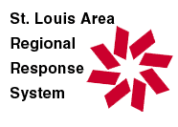 | STARRS Hospital: Amateur Radio Network

SUBJECT: CREDENTIALING OF AMATEUR RADIO EMERGENCY COMMUNICATIONS VOLUNTEERS

RELATED
REFERENCES:

OFFICES AFFECTED
BY POLICY:

Effective  Date: | Revised  Date: | Reviewed  Date:

DEFINITIONS

RESPONSIBILITY AND DUTIES
- Responsible Office/Bureau/Program

The responsible individual for implementing this Policy and Protocol is the Hospital Amateur Radio Volunteer Coordinator. This is the individual appointed by the individual hospital that is to coordinate the communications efforts of the Radio Volunteers

SECTION 1: PURPOSE

To define the policy and procedures that will assist hospitals and hospital groups to provide access for volunteers that will be assisting the hospitals with emergency Amateur Radio communications.

SECTION 2: STANDARDS/PROCEDURES

- Identification methods for volunteers involved in assisting hospitals with Amateur Radio Emergency Communications
- Local Amateur Radio Emergency Services (ARES) Members
In a number of counties in Missouri and Illinois, Amateur Radio Emergency Services (ARES) organizations are available to assist hospitals in identifying and documenting qualified Amateur Radio Licensees. Many such organizations have implemented picture Identification Cards for use by their members. A listing of the membership of such organizations could be obtained and could be the basis of a hospital’s identification and authorization for admittance to hospital facilities in the time of activation of the need for such services. Such member information should provide the class of the communications privileges, technician, General, Extra, as well as their Call Sign, and any FEMA and ARRL training that the individual has taken. However, ARES does not do a background or health check on any ARES member. A picture of the local ARES ID card is presented in Appendix A of this Policy statement.

- Identification by examining an individual’s Federal Communication Commission (FCC) license and State issued identification card or drivers license could be used by hospitals to verify that an individual could be admitted to serve in the time of activation of the need for emergency communications services. Pictures of Amateur Radio FCC issued licenses are documented in Appendix B of this Policy statement. However, such a method does not result in the performance of a background or health check of the volunteer. Nor is there and assurance that the volunteer has been trained in the needs, policies, or protocol or the hospital.
- Centrally maintained listings of qualified Amateur Radio licensees could be utilized to ensure that personnel have received the necessary training to operate and function in the Amateur Radio Emergency Communications facility and hospitals could utilize this information to allow access to their facilities in time of need. E-sponder may provide such information.
- A hospital may decide to utilize its existing volunteer identification system to identify qualified Amateur Radio Emergency Communications personnel.
Each of the above methods of identification has pros and cons as to the validity of the identification and the tracking of training and other admittance criteria. Hospitals must make their own decisions in this area in accordance with their existing policies and procedures.

- Basic Information believed to be needed to authorize admission during emergency operations.
Should a hospital wish to collect information to validate the volunteer’s qualification to serve in such an effort, the following listing should provide the basic information that should be collected and recorded for each volunteer.
- Personal Identification
  - Name
  - Address
  - Telephone Number or “other how to contact information.”
  - Emergency Contact information
  - Personal references information
  - Volunteer availability information
  - Federal Communications Commission (FCC) license, call sign and rating (Technician, General, or Extra. These are explained in Appendix C of this Policy statement), and expiration of said license. Not required for non-licensed personnel assisting in the operation of the Amateur Radio Emergency Communications facility.
- Background check information
  - Background check information if the hospital requires background checks to be performed of volunteers.
- Training history information
  - Training history information to ensure that the individual has obtained the necessary training to adequately function in Amateur Radio Emergency Communication effort.
  - Exercise and Drill participation information.
  - Attendance information for any hospital required orientation or training.
- Any other information normally collected on hospital volunteers such a birthdays, relatives volunteering at the facility, etc.

Approvals:
(Title): |  | Date:
(Title) |  | Date:
 |  | Date:

No. of Attachments: 2

APPENDIX A

AMATEUR RADIO EMERGENCY SERVICES (ARES)
IDENTIFICATION CARD

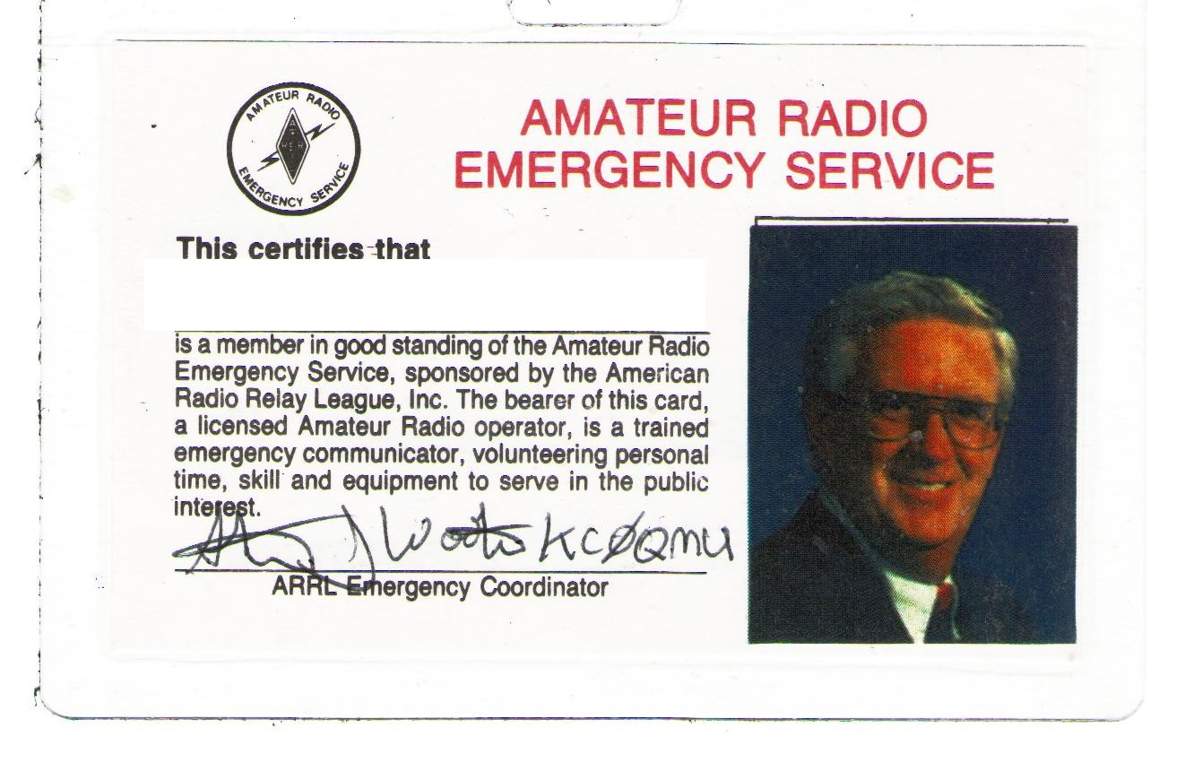

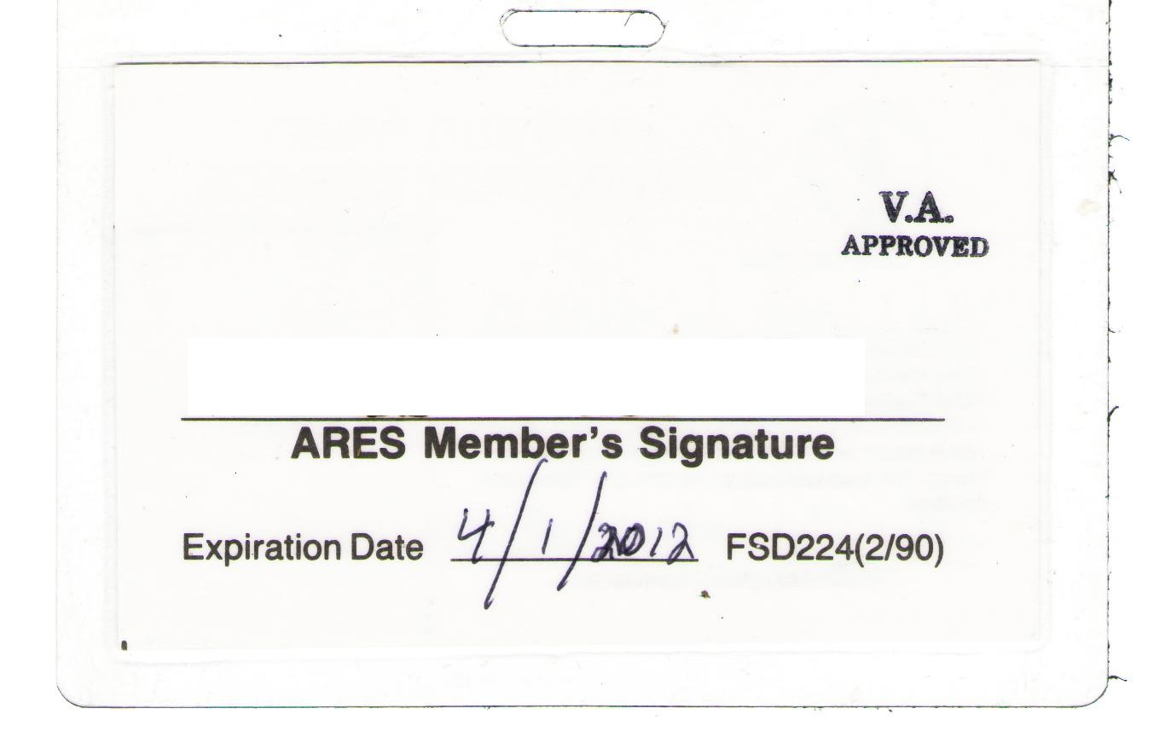

APPENDIX B

FEDERAL COMMUNICATIONS COMMISSION
AMATEUR RADIO LICENSE

